igcesh2020
Universiti Teknologi Malaysia, Johor Bahru, Malaysia 17 -19 August 2020

EXTENDED ABSTRACT TITLE

First Author¹, Second Author*² and Third Author³ (Full Name)

^{1, 2} Authors’ Department, Institute, City, COUNTRY.
(E-mail: firstauthorsname@aaaa.bbb, *secondauthorsname@aaaa.bbb)
³ Author’s Department, Institute, City, COUNTRY.
(E-mail: thirdauthorsname@aaaa.bbb)

ABSTRACT
The abstract should be written in 10-points Times New Roman and not be more than 200 words each. The abstract should not only indicate the subject and scope of the paper but also summarize the author’s conclusion. Structured abstract must be a brief, comprehensive summary of the contents of the article. It allows readers to survey the contents of an article quickly. An Abstract summarizes the major aspects of a paper. It should succinctly summarize the purpose of the paper, the methods used, the major results, and conclusions.
Keywords: Keyword 1, Keyword 2, Keyword 3 (Min 3 key words & Max 5 Key words)

INTRODUCTION
This format is to be used for submissions of extended abstract that will be published in the proceeding of the IGCESH2020. We wish to give this proceeding a consistent, high-quality appearance. We therefore ask that authors follow some simple guidelines. In essence, you should format your paper exactly like this document. The easiest way to do this is simply to download a template from the conference web site and replace the content with your own material.

In this section, author should address the following information which is background, objectives and methodology of the research.

The extended abstract should be written in MS Word format in single-spaced in 12-point Times New Roman except for abstract. Do not indent the text paragraphs. Each paragraph must be a single-spacing separated (Click icon ‘¶’ at the Home Tools).

Please briefly explain the aim and scope of the study, the materials and methods, and the main findings and brief analysis of the study. Please observe Figure 1 and Table 1 to include figures and tables in the manuscript, respectively. The in-text citation of the manuscript should be in numbered (Vancouver) with a square bracket ‘[]’only.

Authors are requested to submit the Extended Abstracts (maximum of 5 pages in the length including the references and pages should not be numbered) in electronic form (MS-Word) via our Online Submission. The incorrect formats may result in your abstract being returned to you by e-mail. The scientific committee will select the contributions for oral and poster presentations.

A digital version of the IGCESH2020 Proceeding will be published in the conference website. After the conference, selected submissions will be invited to be extended into full papers for publishing in SCOPUS indexed journals or periodicals.

MAIN RESULTS
In this section, author should address the following information which is finding and discussion. Figures can be included in your extended abstract and referred to in the text. Please ensure that the figure and caption are inserted in the text box provided below (Click ‘View Gridlines at the ‘Borders’ icon to understand better).

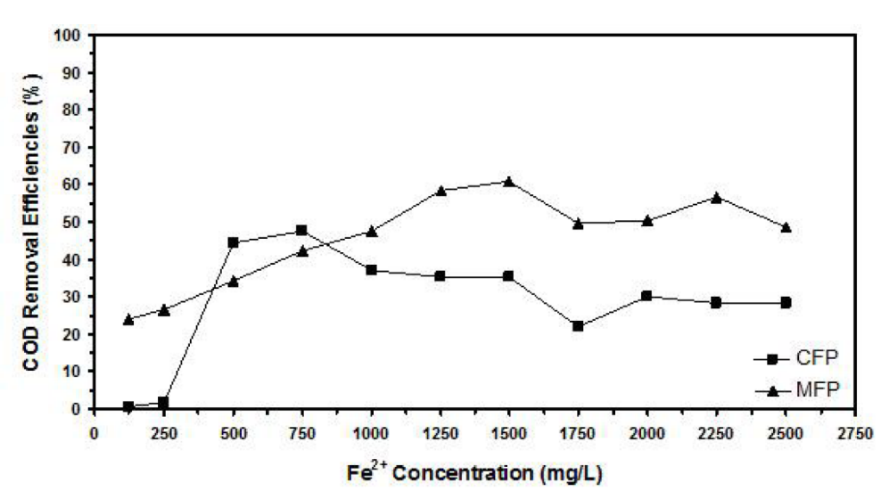
Figure 1. Example of figure for the full paper.

A table should be inserted like the one below and referred in the text. Please avoid vertical rules and shading in table cells.

Table 1. Example of table for the extended abstract
Contents of Table

A maximum of 1 table and 1 figure is allowed.

CONCLUSION
The conclusion is intended to help the reader understand why your research should matter to them after they have finished reading the paper. A conclusion is not merely a summary of the main topics covered or a re-statement of your research problem but a synthesis of key points and, if applicable, where you recommend new areas for future research.

Acknowledgment: The authors would like to express their appreciation for the support of the sponsors with Project No xxxx.

REFERENCES (Numbered, Vancouver Style)
- Author. Title. Journal. Year; Volume (Issue): Pages. (Journal Article)
- Author. Title. Conference Name; Date; Conference Location. Place Published: Publisher; Year Published. (Conference Papers)
- Author. Title. Conference Name; Year of Conference Date; Conference Location. Place Published: Publisher; Year Published. (Conference Proceedings)
- Schwartz, M. Title. Edition. Series editors. Place Published: Publisher; Year Date. Number of Pages. (Book)
- Author. Title. In: Editor’name, editor. Book Title. Series Title. Volume. Edition. Place Published: Publisher, Year. Pages. (Book Section)
- Author. Title [Thesis Type]. Place Published: University; Year. (Thesis)

