**IGCESH2024**

Universiti Teknologi Malaysia, Johor Bahru, Malaysia 27 - 28 August 2024

**FULL PAPER TEMPLATE FOR 10TH INTERNATIONAL GRADUATE**

**CONFERENCE ON ENGINEERING SCIENCE & HUMANITIES 2024**

**(IGCESH2024)**

**First Author1, Second Author*2 and Third Author3 (Full Name)**

1, 2 Authors’ Department, Institute, City, COUNTRY.

(E-mail: firstauthorsname@aaaa.bbb, *secondauthorsname@aaaa.bbb)

3 Author’s Department, Institute, City, COUNTRY.

(corresponding email: [thirdauthorsname@aaaa.bbb](mailto:thirdauthorsname@aaaa.bbb))

**ABSTRACT**

All manuscripts should be accompanied by an abstract, of not more than 200 words each, written in English. The abstract should not only indicate the subject and scope of the paper but also summarize the author’s conclusion. Structured abstract must be a brief, comprehensive summary of the contents of the article. It allows readers to survey the contents of an article quickly. This abstract summarizes the major aspects of a paper. It should succinctly summarize the purpose of the paper, the methods used, the major results, and conclusions.

**Keywords: Keyword 1, Keyword 2, Keyword 3 (Min 3 key words & Max 5 Key words)**

**INTRODUCTION**

This template explains and demonstrates how to prepare your IGCESH2024 full paper to be considered in journal publication. The best is to read these instructions and follow the outline of this text. Please make the page settings of your word processor to A4 format (21 x 29.7 cm or 8 x 11 inches); with the margins: bottom 1.5 cm (0.59 in) and top 2.5 cm (0.98 in), right/left margins must be 2 cm (0.78 in).

This format is to be used for submissions to be considered in journal publication. We therefore ask that authors follow some simple guidelines. In essence, you should format your paper exactly like this document. (Sorenzo & Grassi, 2014) The easiest way to do this is simply to download a template from the conference web site and replace the content with your own material. The maximum number of words for review paper/ social sciences are about 5000-7000 while for technical paper are about 3000-5000.

The full paper should be written in MS Word format, preferably as .doc file. Use single spaces in 12-point Times New Roman except for abstract (10.5-points Time New Roman). Please indent the text paragraphs. Please state clearly the aim (and scope) of the study, the materials and methods, and the main findings and brief analysis of the study. Please observe Figure 1 and Table 1 to include figures and tables in the abstract, respectively.

Authors are requested to submit the full paper (8 to 12 pages in length) in electronic form (MS-Word) via email or our online submission. The incorrect formats may result that your full paper will not be considered for journal publication.

**MAIN RESULTS**

The section headings are in boldface capital and uppercase letters.

**Sections Headings**

Second level headings are typed in italic boldface with capital first letters (like the subsection heading of this paragraph).

Figures can be included in your paper and referred to in the text as Figure 1, Figure 2, and so on. Please ensure that the figures are inserted in the text box provided below.

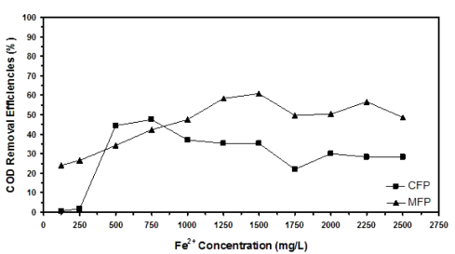

**Figure 1.** Example of figure for the full paper.

A table should be inserted like the one below and referred in the text as Table 1, Table 2, and so on. Please avoid vertical rules and shading in table cells.

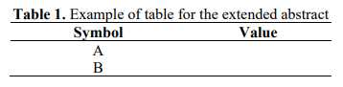

**Special Signs**

For example, α γ μ Ω () ≥ ± ● Γ {11 0} should always be written in with the fonts Times New Roman or Arial, especially also in the figures and tables.

**Equations**

Equations (refer with: (1), (2), ...) should be indented. It is recommended to have one line of space above the equation and one line of space below it before the text continues. The equations have to be numbered sequentially, and the number put in parentheses at the right-hand edge of the text. Equations should be punctuated as if they were an ordinary part of the text. Punctuation appears after the equation but before the equation number, e.g.



**CONCLUSION**

The conclusion is intended to help the reader understand why your research should matter to them after they have finished reading the paper. A conclusion is not merely a summary of the main topics covered or a re-statement of your research problem but a synthesis of key points and, if applicable, where you recommend new areas for future research.

**ACKNOWLEDGEMENT**

The authors can add in the acknowledgement if they would like to express their appreciation for the support of the sponsors with certain Project No, individual or organization/institution.

**REFERENCES**

A reference as follows:

Surname, A., & Surname, B. (Year). Title. *Journal, Volume.* URL.

* When you had 3 to 5 authors, it was necessary to list them all in APA 6th Edition and only then use the “et al.” part. Now the newest edition must use “et al.” citing when you have 3 or more than 3 authors.
* The words “Retrieved from” or “Accessed from” are no longer necessary before the URL in APA 7th edition.

For example:

Sorenzo, A., & Grassi, M. (2014). Psychoacoustics: a comprehensive MATLAB toolbox for auditory testing. *Frontiers In Psychology, 5*. https://doi.org/10.3389/fpsyg.2014.00712