**UGE COURSE OFFERED BY AHIBS**

**(SEMESTER 1-2024/2025)**

**UBSS6013 ORGANIZATION BEHAVIOUR & DEVELOPMENT**

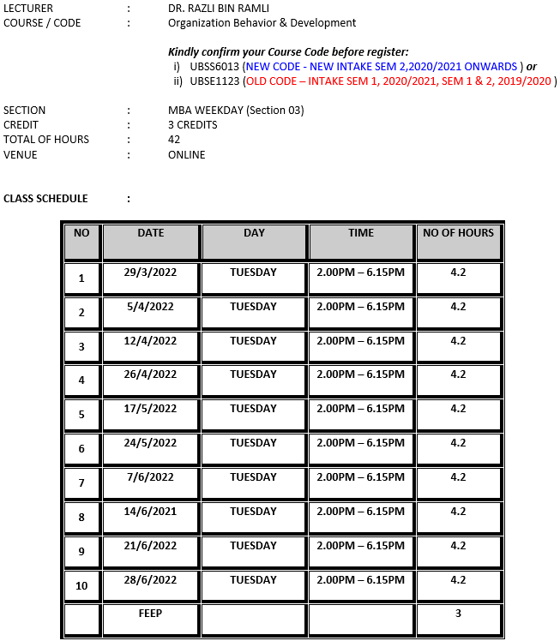

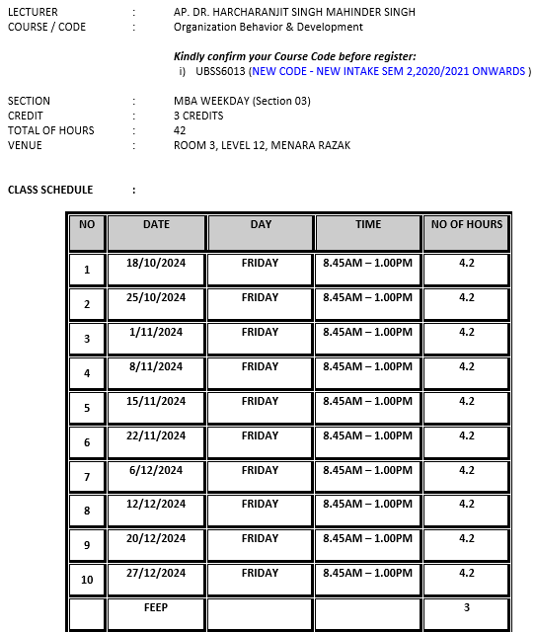

**UBSS6013 BUSINESS ETHICS, RESPONSIBILITY AND SUSTANAIBALITY**

